Resume  Santosh Paikrao  M.Sc. (Agri) Agronomy.  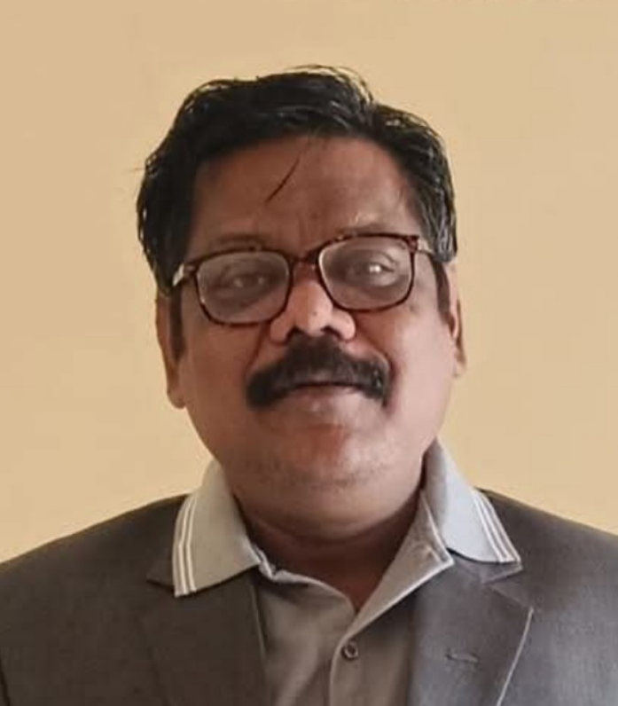  Email Adresse :  raosantosh_2015@yahoo.com  Permanent Address:  Near Gram panchayat Karyalaya  Shrirampur. Post-Shrirampur  Taluka-Pusad, Dist- Yavatmal  Pin-445215  Personal Information  Date of Birth : 12 August 1976  Sex : Male  Nationality : Indian  Marital Status : Married  Father’s Name : Madhukar Paikrao  Languages : Marathi, Hindi, English.  Phone number : 9921586232 | Objective  To strive for the development of the organization through constant information and Creativity.  To strive for personal development by being pro-active and technically updated.  To strive for excellence by accepting new, diverse and challenging roles and Responsibility.  To get a position where I can put me as good Marketing Management professional.  Major Strengths  - Enthusiastic, Confident & Energetic  - Believe in Punctually, Patience & Dedication.  - Listener and speaker.  - Smart working as per demand.  - Positive Attitude. Work in pressure and critical condition.  Educational Qualification  Course Institution Board/ Year of Marks %  University Completion  M.Sci Agronomy Dr.PDKV, Akola Dr. PDKV, Akola 2002 78.00%  B.Sci. Agri SSAC, Amravati Dr. PDKV Akola. 2000 70 .7  Experience  Organization Designation Total Area Cover  Genomix AGPL (Kaveri Group) Regional Business Manager 2021 to till date Vidarbha Region  Rasi Seeds (P) Ltd. Regional Crop Manager 2017 to 2021 Vidarbha Region.  Rasi Seeds (P) Ltd. Territory Manager 2012 to 2017 Yavatmal Chandrapur  JK Agri Genetics Sales Officer 2007 to 2012 Buldana  JK Agri Genetics Asst.Sales Officer 2004 to 2007 Raipur (CG)

Job Roll
- Develop sales, collection and built the Sales network.
- Arrange the training of Sales staff to develop their technical knowledge about hybrid and cultivation management.
- Farmer meeting in village level and aware them about new technology.
- Provide the information to the research team keeping in view the needs of farmers.
- Guide to Sales team for Placement and liquidation of hybrids as per segment .
- Market research and collect data from various sources for generating Business.
- Searching new opportunity for product fitment in market..
- Competitor Analysis and help to improve Sales channel & New Dealer appointment.
- Budgeting of Product development activity.
- Advertisement, Promotion & Branding of new product..
Achievements
- First Prize in Sales as a Territory Manager (2015 & 2016) and Best Performance (2018).
- Awarded for New Concept of Soil segmentation and hybrid wise agronomy practice developed in 2017.
- Within a 3 Years got promoted.
Extra Curricular Activities & Skill
- Participate in College NSS programmed of inter University level.
- Excel, MS-Document, Power Point Presentation etc.
Salary Details
- Current CTS -12.58 Lac
- Expected CTC- 16 Lac
- Notice Period -20 Days to 3 Month.
Declaration
I am Mr. Santosh Madhukar Paikrao hereby declare that the above written particulars are true to the best of my knowledge and belief.
Date: 26/07/2025 yours truly,
Place: Yavatmal ( Santosh Paikrao )

